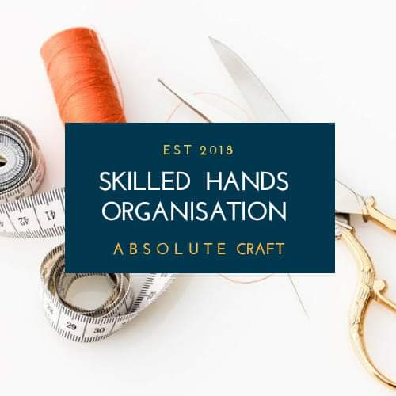
PHOTO
Skilled Hands Organisation
Tel: 074 86 87 6873
Email: skills.hands.org@gmail.com

APPLICANT REGISTRATION FORM
ARTISAN CRAFT & SMALL BUSINESS WORKSHOP
TAILORING, BAG MAKING,
JEWELLERY MAKING & MILLINERY (Virtual Workshop)

FULL NAME…………………………………………………………………………………………………………………..
DATE OF BIRTH……………………………………………………………………………………………………………..
AGE…..………………………………………………………………………………………………………………………….
ADDRESS………………………………………………………………….. …………………………………………………
……………………………………………………………………………………………..………………………………………
EMAIL……………………………………………………………………………………………………………………………
CONTACT NUMBER: ……………………..………………………………………………………………………………
SECOND CONTACT PERSON: ..……………………………………………………………………………………….
ETHNICITY……….…………………………………………………………………………………………………………….
RELIGION…………………………...…………………………………………………………………………………………
MARITAL STATUS………………..…………………………………………………………………………………………
DO YOU HAVE ANY CHILDREN? ...... YES / NO
ARE YOU CURRENTLY EMPLOYED (If yes please state your occupation and if full or part time employment)
………………………………………………………………………………………………………………………………………
NATIONAL INSURANCE NUMBER: …………………………………………………………………………………

ARE YOU IN RECEIPT OF ANY GOVERNMENT BENEFITS? (If yes please state below and attach a photocopied evidence to this application)
……………………………………………………………………………………………………………………………………….

IF YOU ARE EMPLOYED, ARE YOU A LOW INCOME EARNER? (If yes, do you earn less than £16,000 a year?)
………………………………………………………………………………………………………………………………….

WHY ARE YOU TAKING PART IN THIS WORKSHOP? PLEASE TICK AS MANY AS YOU CAN
- MEET AND MAKE NEW FRIENDS
- LEARN A NEW CRAFT SKILL
- LEARN A NEW CRAFT SKILL AND START A SMALL BUSINESS

AS A REQUIREMENT, PICTURES AND VIDEOS ARE ALWAYS TAKEN DURING OUR SESSIONS, THESE MAY BE SHARED WITH FUNDERS, THE MEDIA (newspaper and on TV) OR ON OUR SOCIAL MEDIA PLATFORMS. PLEASE SELECT MOST APPRIOPRIATELY
- YES, I DON’T MIND SHARING PICTURES OF ME IN THE MEDIA
- NO, I WILL PREFERE NOT TO SHARE PICTURES OF ME IN THE MEDIA

HOW DID YOU HEAR OF THIS WORKSHOP?
…………………………………………………………………………………………………………………………………

PLEASE STATE YOUR PREFERRED COURSE: ………………..……………………………………………

WHAT IS YOUR PROFICIENCY LEVEL IN THE ENGLISH LANGUAGE?
Spoken: ( ) Excellent ( ) Good ( ) Fair ( ) Limited
Written: ( ) Excellent ( ) Good ( ) Fair ( ) Limited

BY SIGNING THIS FORM, YOU AGREE THAT:

- INFORMATION GIVEN ON THIS FORM IS VALID AT THE TIME OF APPLICATION
- YOU WILL PROVIDE A CURRENT COPY OF YOUR PROOF OF BENEFIT
- YOU WILL COMMIT TO ATTENDING THE FULL WORKSHOP WHICH IS FULLY FUNDED.
- YOU WILL RETURN ALL TOOLS AND REMAINING MATERIALS GIVEN TO YOU BY THE ORGANISATION IN GOOD CONDITION BY THE END OF YOUR COURSE.
- IF YOU MISS THE WORKSHOP ON THREE (3) COUNTS WITHOUT ANY RELEVANT PROOF
OF ABSENCE, YOU WILL HAVE TO PAY SKILLED HANDS AN AMOUNT OF £60 FOR CAUSING
FINANCIAL LOSS TO THE ORGANISATION AND YOU WILL NOT RECEIVE A CERTIFICATE OF
PARTICIPATION FROM US AT THE END OF THE PROGRAMME
- YOU WILL PAY A REFUNDABLE DEPOSIT OF £20 AS SECURITY FOR USING OUR TOOLS, MATERIALS AND FOR YOUR COMMITMENT TO THE PROGRAMME. AT THE END OF THE PROGRAMME YOUR £20 DEPOSIT WILL BE GIVEN TO YOU IF OUR TOOLS AND REMAINING MATERIALS ARE RETURNED IN GOOD CONDITION.
- IF YOU ARE A PAID PARTICIPANT AND YOU MISS 3 WORKSHOPS WITHOUT RELEVANT PROOF
OF ABSENCE, YOU WILL LOOSE YOUR PLACE IN THE WORKSHOP AND YOUR MONEY WILL NOT
BE REFUNDED, AGAIN, YOU WILL NOT RECEIVE A CERTIFICATE OF PARTICIPATION FROM US AT
THE END OF THE PROGRAMME
- YOU WILL TAKE GOOD CARE OF ALL MATERIALS AND TOOLS PROVIDED BY THE ORGANISATION
- YOU WILL RETURN ALL TOOLS AND REMAINING MATERIALS IN GOOD CONDITION AT THE ENT OF THE TRAINING.
- YOU WILL PARTICIPATE AND ENGAGE IN ALL ACTIVITIES HELD BY THE ORGANISATION
- YOU WILL TREAT THE TRAINER, VOLUNTEERS AND PARTICIPANTS WITH RESPECT

SIGNATURE OF APPICANT:
DATE:

